SENIOR RESIDENT PRESENTERS

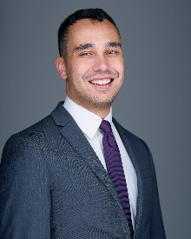
Anson G. Bautista, MD
Faculty/Research Mentor:
Adam Pearson, MD, MS

Biography:

Dr. Bautista graduated from Marquette University with a Bachelor of Science in Biomedical Sciences. Dr. Bautista earned his Doctorate of Medicine from Columbia University Vagelos College of Physicians & Surgeons. Following graduation, he will complete a one-year Spine Surgery Fellowship at New England Baptist.

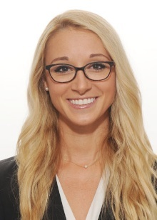
Ann Marie Kelly, MD, MS
Faculty/Research Mentor:
Daniel Austin, MD, MS

Biography:

Dr. Kelly graduated from University of Notre Dame with a Bachelor of Arts in English, Pre-Medical. She also earned her Masters of Science in Global Health at the University of California, San Francisco. Dr. Kelly earned her Doctorate of Medicine from Sidney Kimmel Medical College at Thomas Jefferson University. Following graduation, she will complete a one-year Sports Medicine Fellowship at University of Virginia.

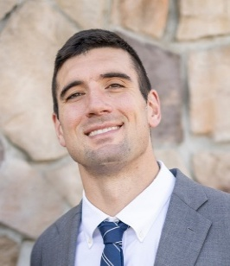
Patrick M. Mazza, MD
Faculty/Research Mentor:
Wayne Moschetti, MD, MS

Biography:

Dr. Mazza graduated from University of Notre Dame with a Bachelor of Science in Pre-professional Studies. He earned his Doctorate of Medicine from Loyola University Chicago Stritch School of Medicine. Following graduation, he will complete a one-year Arthroplasty Fellowship at UCSF.

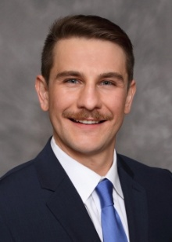
Michael A. McNamara, MD
Faculty/Research Mentor:
Alexander Boys, PhD

Biography:

Dr. McNamara graduated from Georgetown University with a Bachelor of Science in Biochemistry and Philosophy & Bioethics. He earned his Doctorate of Medicine from the Medical College of Wisconsin. Following graduation he will complete a one-year Shoulder/Elbow Fellowship at Northwestern and is currently applying for an Orthopedic Oncology fellowship to follow.

Dartmouth Orthopaedic Department
Event Planning Committee
Marcus P. Coe, MD, MS, Program Director
Daniel C. Austin, MD, Associate Program Director
Chief Residents: Drs. Anson Bautista, Ann Marie Kelly, Patrick Mazza, and Michael McNamara
Penny Atherton, C-TAGME, Residency Program Coordinator

DARTMOUTH
ORTHOPAEDIC SURGERY
SENIOR RESEARCH DAY

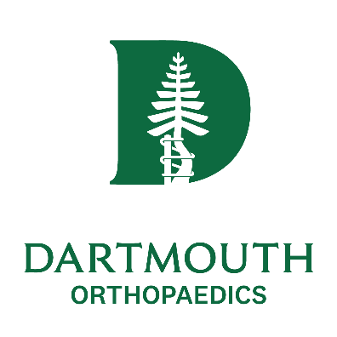

Friday, October 9, 2026
Simon Pearce
Quechee, VT

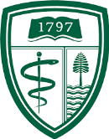



VISITING PROFESSOR

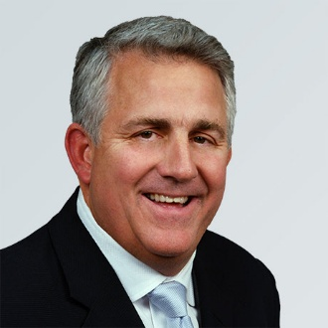

Augustus C. Mazzocca, MD
Medical Director
Massachusetts General Brigham
Sports Medicine

Augustus "Gus" Mazzocca, MD, is the medical director of Mass General Brigham Sports Medicine. He is also the chief of Mass General's Sports Medicine Service and the director of the Bioskills, Biomechanics and Cell Biology Laboratories within the Department of Orthopaedic Surgery at Mass General. Alongside these posts, Dr. Mazzocca serves on the faculty of orthopaedic surgery at Harvard Medical School.
Dr. Mazzocca earned his Bachelor of Science in biology from Denison University, a Master of Science in applied physiology from Springfield College and his medical degree from the University of Connecticut School of Medicine. He completed an internship and residency with the Department of Orthopaedic Surgery at the University of Connecticut School of Medicine, as well as a fellowship in Sports, Shoulder and Elbow Surgery at Rush University in Chicago.
Dr. Mazzocca is an internationally renowned shoulder and elbow clinician specializing in complex joint injuries and conditions.

Dartmouth Orthopaedics
Senior Research Day
Friday, October 9, 2026

3:00 Welcome—Daniel Austin, MD, MS

3:15 Chief Introduction:
Adam Pearson, MD, MS

3:20 Anson G. Bautista, MD
Topic: “Use of Kickstand Rod Improves Coronal Alignment and Maintains Correction Compared to Control at 2-year Follow-up”

3:50 Chief Introduction:
Daniel Austin, MD, MS

3:55 Ann Marie Kelly, MD, MS
Topic: “Ideal Anchor Design in a Novel Anterior Shoulder Instability Model”

4:25 Chief Introduction:
Wayne Moschetti, MD, MS

4:30 Patrick M. Mazza, MD
Topic: “Radiographic Factors Associated with Tibial Metaphyseal Sleeve Survivorship in Revision Total Knee Arthroplasty: A Matched Cohort Study”

5:00 Chief Introduction:
Alexander Boys, PhD

5:05 Michael A. McNamara, MD
Topic: “Investigating Osteocyte Behavior Using Real-Time Bioelectronic Measurements”

5:35 Introduction of Guest Speaker:
John-Erik Bell, MD

5:40 Augustus C. Mazzocca, MD
Topic: “No One Cares Where You Are at 4:00 a.m.: Reframing Success for the Modern Orthopaedic Surgeon”

6:15 Closing Remarks:
Daniel Austin, MD, MS

6:30 Reception

7:00 Dinner

Accreditation

In support of improving patient care, Dartmouth Health is jointly accredited by the Accreditation Council for Continuing Medical Education (ACCME), the Accreditation Council for Pharmacy Education (ACPE), and the American Nurses Credentialing Center (ANCC), to provide continuing education for the healthcare team.

American Medical Association (AMA)

Dartmouth Health designates this live activity for a maximum of 2.5 AMA PRA Category 1 Credit(s)™. Physicians should claim only the credit commensurate with the extent of their participation in the activity.

Learning Objective

At the conclusion of this activity, participants will be able to discuss at least two evidence based clinical practice changes in the care of the orthopaedic surgery patient.

